Informed Consent Form
Template

Gray markers and callouts in this template indicate applicable GCP provisions.
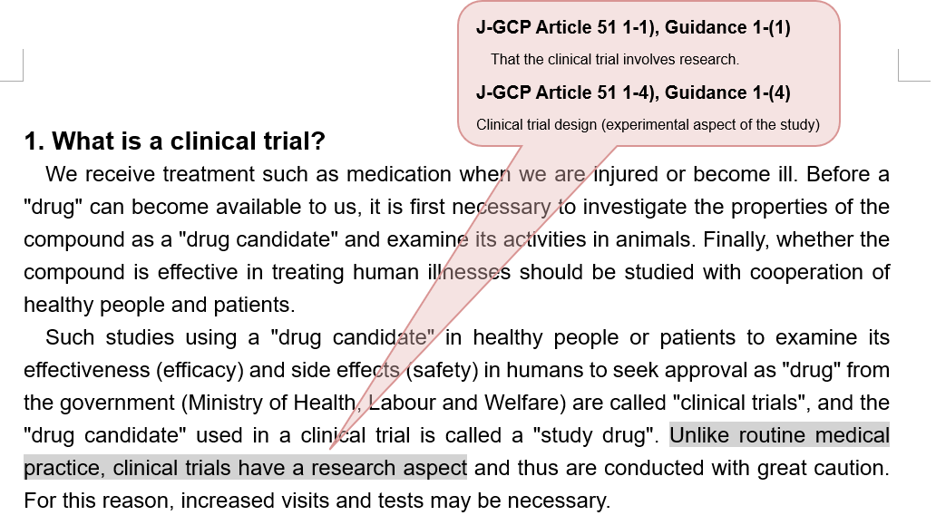

Blue text indicates where specific information should be inserted. Change the text according to the study-specific information.

The boxes (green background) provide the preparation guide. Remove the preparation guide before finalizing the document.
Preparation guide)

Common ICF Template (Ver.1.1 14 March 2023)
<<How to prepare an Informed Consent Form>>
Note the following guidance when preparing an Informed Consent Form.

General
- Technical terms should be annotated. Kanji letters that are difficult to read and English terms should be explained when they appear for the first time etc.
- Efforts should be made to improve readability (e.g., color text, bold letters, underlining, line-spacing expansion, illustration insertion).
- If a single study has multiple parts or cohorts,
  - consider preparing the Informed Consent Form separately for each part/cohort for better differentiation in the document as appropriate (e.g., summary part, study schedule).
- When a URL is provided, also consider using a QR code.
- The term "clinical research coordinator" in the template may be changed to the site-specific term.

This template document consists of the following.
Do not change the document structure or the order of headings in each part. Additional items, if any, should be inserted at the end of the applicable part.
A) Summary of the clinical trial
- A summary of the study is provided on about 2 pages.
B) General description about clinical trials
- A common explanation is given regardless of the medical institution, sponsor, or study.
- In principle, the template text should not be changed.
- Regarding the contents of the given study, the same information as in "A) Summary of the clinical trial" should be given in the description boxes.
- Any necessary study-specific addition or supplement should use "D) Additional or detailed information".
C) Description of this clinical trial
- This part should be prepared based on the protocol contents etc.
- The study drug appearance, packaging, route of administration, visit/dosing schedule, and a list of adverse events should be in line with the protocol contents etc. Consider using figures/tables.
D) Additional or detailed information
- As opposed to "B) General description about clinical trials", this part should provide the information specific to the medical institution, the sponsor, or the study (e.g., summary of the compensation system, handling of personal information, actions in the event of a large-scale disaster, other additional or detailed information).
- Description of the compensation system
  - A document stating a summary of the compensation system should be either included in or attached as an appendix to the information sheet.
Consent Form
- Use a replicate form as necessary (Example: in triplicate in the order of "For filing in medical record", "For file at secretariat", and "For patient").
- Modify the number and order of replicates and the financial account number section to match the operation of the medical institution.
*If the financial account number section is given, no copy "For filing in medical record" is required
- Use the "Witness", "Legally acceptable representative", and "Proxy signatory" fields as needed.

Please read carefully.

About the clinical trial of (name of study drug) for (name of disease)
Patient Information and Consent Form

This booklet describes a clinical trial of XXX.
Please read this information sheet carefully and understand the contents of the clinical trial before making your decision whether you would like to take part in the clinical trial. You are free to decide whether or not to take part. You will not be disadvantaged in any way by declining to participate. You may withdraw from the trial at any time even after you have once agreed to participate in the trial or after the trial has started.
If you have questions or concerns about the contents, please feel free to ask the study doctor or clinical research coordinator.

Preparation guide)
- Insert illustrations as appropriate.
- Choose illustrations that are appropriate for the study or subjects.

- Study title
  - When simplifying the title, consider identifiability of the study during a Web search.
    - Japan Registry of Clinical Trials Portal Site (https://rctportal.niph.go.jp/ ), IRB minutes summaries, etc.)
  - Supplement verbally when necessary

Study title:

Table of Contents
Table of Contents 5
A. Summary of the clinical trial 6
1. Summary of the clinical trial 7
B. General description about clinical trials 10
1. What is a clinical trial? 11
2. Voluntary participation in the study 13
2-1. Study participation and withdrawal 13
2-2. Notification of new information 13
3. Contact information 13
4. Costs during the study 14
5. Payment to reduce burden 15
6. Institutional Review Board that has reviewed this study 15
7. Protection of personal information 16
8. Compensation in the event of health injury 18
C. Description of this clinical trial 19
1. About your disease and treatment 20
2. About the study drug 20
3. Objectives of the clinical trial 20
4. Clinical trial design 20
4-1. Criteria for participation in the study 20
4-2. Study procedures 21
4-3. Study schedule 22
5. Possible benefits and disadvantages 22
5-1. Foreseeable benefits 22
5-2. Foreseeable side effects or adverse events 22
5-3. Foreseeable disadvantages 22
6. Alternative treatment methods 23
7. Possible discontinuation of the study 23
8. Your responsibilities during the study period 23
D. Additional or detailed information 25
1. (Example) Summary of the compensation system 26
2. (Example) Handling of personal information 27
3. (Example) Actions in the event of a large-scale disaster 28
Consent Form 29

A. Summary of the clinical trial

Part 1: Summary of the clinical trial

- A 1- or 2-page summary of the study should be given.
- Detailed explanation of the specific study should use Part 3 "C. Study-specific items".

(Remove this annotation box before finalizing the document.)

1. Summary of the clinical trial
This is a summary of this clinical trial. For details, please see the relevant section of the main text.
Study Summary
Target disease//condition  (Section C-1, p.20) | [Disease//Condition]
Objective(Section C-3, p.20) | To examine the effectiveness and safety of [study drug name/code] (under development in Japan) for the treatment of [Disease/Condition]  (Phase X study)
Dosage form of the study drug,  method of administration (use), dosage  (Section C-4, p.20) | [Dosage form of the study drug] ([Dosage])
Planned duration of participation and flow  (Section C-4, p.20) | - X days from the start to the end of the study  J-GCP Article 51 1-7), Guidance 1-(7)  Duration of the subject’s participation in the clinical trial  J-GCP Article 51 1-16), Guidance 1-(13)  Planned number of subjects who will participate in the study  - About XX weeks, about X visits
Planned number of participants | About XX persons
Sponsor | Company sponsoring the study at this hospital: XXXX Corporation
Costs during the study  <Sponsor's coverage:  You will be charged no cost.>  (Section B-4, p.14) | The following costs are incurred at this hospital during the applicable period  Applicable period:  First day of study drug intake/use to the last day of study drug intake/use or the day on which discontinuation is decided  - Costs of all tests  - Costs of all imaging examinations  - Costs of any medication with the same effect as the study drug (if applicable)  - Other costs of the following as necessary to cover the costs of tests performed for the study outside the study treatment period (if applicable)
Costs during the study  <Coverage by health insurance:  You will be charged the copayment.>  (Section B-4, p.14) | - Initial visit fee, revisit fees  - Treatment costs except for [disease //condition]  J-GCP Article 51 1-16), Guidance 1-(16)  Costs to be charged to the subject if any
Payment to reduce burden  <Payment to you for your participation>  (Section B-5, p.15) | X,XXX yen per visit or admission/discharge for the study  Applicable period: Example) From the date of informed consent to the end of the observation period  Payment method:  Example) The money will be transferred in a monthly batch to your designated financial account in the following month.
Institutional Review Board  (Section B-6, p.15) | Name: XXXXX Institutional Review Board  J-GCP Article 51. 1-15), Guidance 3,4  Matters concerning the Institutional Review Board  Type: Institutional Review Board  Founder: Director of XXXXX  Address: XXX [prefecture] XXX  The Institutional Review Board's written procedures, member list, and meeting minute summaries are posted on the website of XXXX (https://XXX.XXX.jp/).
Contact information  (Section B-3, p.13) | Principal investigator  Name:  Department:  Contact number: XXX-XXX-XXXX (Main number)  Consultation office  Clinical Research Coordinator:  Contact number: XXX-XXX-XXXX (Main number)  Weekdays XX to XX, Study Management Office (extension: XXXX)  Nights and Holidays (extension: XXXX)
J-GCP Article 51 1-12), Guidance 1-11)
A consultation office at the medical institution where subjects should refer or contact for further information regarding the study and the rights of subjects or in the event of trial-related injury

Preparation guide A):
General:
- If the study has multiple parts or cohorts, the summary may be prepared separately for each part/cohort.
Payment to reduce burden:
- Enter the period, amount, and time of payment in accordance with the rules and practices of the specific medical institution.
Contact information:
- In the principal investigator's section, provide the name and department (the department is not required by GCP but required by this template for possible inquiries from patients).
- Each medical institution may make additions/changes as appropriate (The principal investigator and a consultation office must be stated according to GCP.)
Other:
- If the Japan Registry of Clinical Trials (jRCT) or other study registry websites are available for reference, add the URLs or QR codes.

B. General description about clinical trials
Part 2: Items common to all clinical trials

- Part 2 is a common explanation part regardless of the medical institution, sponsor, or study, and therefore should not be changed in principle.
- Any necessary study-specific addition or supplement should be given in Part 4 (D. Additional or detailed information).

(Remove this annotation box before finalizing the document.)

1. What is a clinical trial?
We receive treatment such as medication when we are injured or become ill. Before a "drug" can become available to us, it is first necessary to investigate the properties of the compound as a "drug candidate" and examine its activities in animals. Finally, whether the compound is effective in treating human illnesses should be studied with cooperation of healthy people and patients.
Such studies using a "drug candidate" in healthy people or patients to examine its effectiveness (efficacy) and side effects (safety) in humans to seek approval as "drug" from the government (Ministry of Health, Labour and Welfare) are called "clinical trials", and the "drug candidate" used in a clinical trial is called a "study drug". Unlike routine medical practice, clinical trials have a research aspect and thus are conducted with great caution. For this reason, increased visits and tests may be necessary.
In addition, participation in a clinical trial must be based on the free will of the participants, and their human rights and safety must be protected to the maximum extent. To ensure this, clinical trials are conducted in accordance with the standards established by the Ministry of Health, Labour and Welfare (Good Clinical Practice [GCP]). In accordance with these standards, implementation of this clinical trial at this hospital has been reviewed and approved by the Institutional Review Board (explained in "6. Institutional Review Board that has reviewed this study").
J-GCP Article 51 1-1), Guidance 1-(1)
That the clinical trial involves research.
J-GCP Article 51 1-4), Guidance 1-(4)
Clinical trial design (experimental aspect of the study)

Processes of clinical trials
A "drug candidate" is first tested in animals in terms of the efficacy and safety before proceeding to a "clinical trial". Clinical trials are conducted usually in three phases, and proceed with confirmation of the efficacy and safety in each phase.
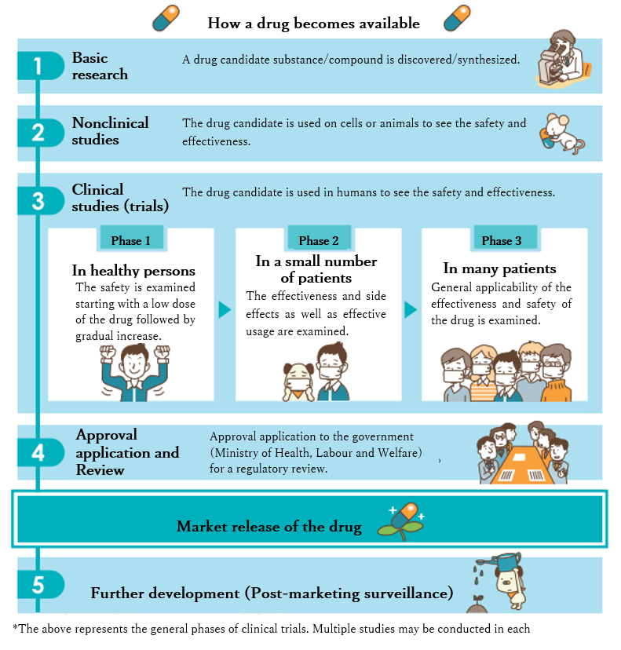
The results obtained from clinical trials are then submitted to the Ministry of Health, Labour and Welfare for a review for approval as a "drug".

Phase 1 trials may be conducted in patients, such as in the case of anticancer drugs.
Source: Japan Medical Association Center for Clinical Trials

2. Voluntary participation in the study

2-1. Study participation and withdrawal
Your decision to take part in this study is voluntary. If you agree to take part, you will be asked to sign the consent form. Even after you have agreed to take part in the clinical trial, you are still free to withdraw or discontinue your participation at any time for any reason by talking to the study doctor or clinical research coordinator. Even if you do not agree to participate or discontinue your participation, you will not be placed under any disadvantage and you can receive treatment suitable to your medical condition.
However, please understand that if you discontinue your participation during the study, your study data up to the time of discontinuation will be used unless you request otherwise. Please also understand that if the timing of your request is after analysis of the data up to withdrawal or after publication of the study results, it may be impossible to delete the obtained results.
J-GCP Article 51 1-8), 9), Guidance 1-(8)
- Subject's participation in the trial is voluntary.
- The subject may refuse to participate or withdraw from the trial at any time.
- The subject is not disadvantaged by refusal or withdrawal.
- The subject does not lose benefits to which the subject is otherwise entitled.
J-GCP Article 51 1-16), Guidance 1-(14)
The subject or subject's legally acceptable representative will be promptly informed if information becomes available that may affect their willingness to continue participation in the trial.

2-2. Notification of new information
You will be promptly notified if new important information becomes available about the study drug during your participation in this study. Each time, you will be asked whether or not you desire to continue your participation in the study.

3. Contact information
If you have any questions, concerns, or worries about this study, please feel free to ask the study doctor or clinical research coordinator any questions. You may discuss with your family or other persons.
It is important that you fully understand the contents of the study and take sufficient time to consider before deciding whether to participate in the study. If you agree to participate in the study, please sign the consent form, and keep this information sheet and the consent form in a safe place.
Contact information | Principal investigator  Name:  Department:  Contact number: XXX-XXX -XXXX (Main number)  Consultation office  Clinical Research Coordinator:  Contact number: XXX-XXX -XXXX (Main number)  Weekdays XX to XX, Study Management Office (extension: XX XX)  Nights and Holidays (extension: XXXX)  Preparation guide)  - In the principal investigator's section, provide the name and department (the department is not required by GCP but required by this template for possible inquiries from patients).  - Each medical institution may make additions/changes as appropriate (The principal investigator and a consultation office must be stated according to GCP.)

4. Costs during the study
You will not be charged for the study drug used in this study. However, for the costs of general medical care, including initial visit fee, revisit fee, hospitalization fee, or medications for other diseases than the target disease of this study, you will need to pay the copayment portion of health insurance. Thus, while you are using the study drug, your medical expenses may be partly reduced.
Costs during the study  <Sponsor's coverage>  You will be charged no cost. | The following costs are incurred at this hospital during the applicable period  Applicable period:  First day of study drug intake/use to the last day of study drug intake/use or the day on which discontinuation is decided  - Costs of all tests  - Costs of all imaging examinations  - Costs of any medication with the same effect as the study drug (if applicable)  - Other costs of the following as necessary to cover the costs of tests performed for the study outside the study treatment period (if applicable)
Costs during the study  <Coverage by health insurance>  You will be charged the copayment. | - Initial visit fee, revisit fees  - Treatment costs except for [disease/condition]

5. Payment to reduce burden
During your participation in the study, you will need to make visits according to the study schedule, possibly more often than usual. Thus, to reduce burden associated with participation in the study, such as transportation expenses, you will be paid a prespecified amount of money per visit or admission/discharge for the study.
This is called "Payment to reduce burden", which is optional and you are free to decide whether or not to receive it.

Payment to reduce burden for this study is as follows.
Payment to reduce burden  <Payment to you for your participation> | X,XXX yen per visit or admission/discharge for the study  Applicable period: Example) From the date of informed consent to the end of the observation period  Payment method:  The money will be transferred in a monthly batch to your designated financial account in the following month.  Preparation guide)  - Enter the period, amount, and time of payment in accordance with the rules and practices of the specific medical institution.

6. Institutional Review Board that has reviewed this study
Clinical trials must be conducted in accordance with the standards for clinical trials established by the Ministry of Health, Labour and Welfare (Good Clinical Practice [GCP]). For the conduct of this clinical trial, the head of the medical institution conducting the trial (director of this hospital) is required to obtain opinions of the Institutional Review Board.
The Institutional Review Board has been established to investigate and deliberate, from scientific and ethical viewpoints, whether there are any problems with the human rights and safety of participants in the clinical trial, upon request by the head of the medical institution. It consists of professionals with expertise in medical care or clinical studies, non-professionals, and persons who is independent of the medical institution.
If you have any questions regarding the Institutional Review Board, please ask the study doctor or clinical research coordinator.

This study has been reviewed and approved by the following Institutional Review Board.
Institutional Review Board | Name: XXXXX Institutional Review Board  Type: Institutional Review Board  Founder: Director of XXXXX  Address: XXX [prefecture] XXX  The Institutional Review Board's written procedures, member list, and meeting minute summaries are posted on the website of XXXX (https://XXX.XXX.jp/).
J-GCP Article 51 1-10), Guidance 1-(9)
That the monitors, auditors, and IRB etc. are given direct access to the source documents on the condition that confidentiality of the subject is fully secured.
J-GCP Article 51 1-11), Guidance 1-(10)
If the study results are published, the subject’s identity will be kept confidential.

7. Protection of personal information
To see whether the clinical trial is properly conducted and the data are accurately recorded, the study-related personnel (qualified sponsor personnel), Japanese and overseas regulatory authorities such as the Ministry of Health, Labour and Welfare, US Food and Drug Administration (FDA), and the European Medicines Agency (EMA) and their related agencies, and the Institutional Review Board that reviews this study may have access to your records such as medical records and laboratory test records. However, these persons are obligated to abide by the laws, regulations, and guidelines to protect personal information, so your name, address, and other privacy information will never be disclosed to others.
Some of your test results before your participation in this study and data collected in this study (including images, audio data, or videos) will be sent to the sponsor. These data obtained from you will be submitted to regulatory authorities in Japan and overseas, including the Ministry of Health, Labour and Welfare (MHLW), as the data to obtain approval of the study drug as a medicinal product. The study results may also be published in medical journals or at academic society meetings. In such instances as well, your name and address and other personal information will not be disclosed. Specifically, your name will not be used but will be replaced by an alphabetic or numeric identification code (coding) for management.
The data obtained from this study and your blood, urine, or other samples provided for this study will not be used for any other purposes. After the end of the study or the storage period, the tested samples will be promptly disposed of in a manner that protects personal information.
Your signed informed consent for participation in the study indicates that you agree to these conditions.
J-GCP Article 51 1-10), Guidance 1-(9)
That by signing the consent form, the subject is authorizing access.

Preparation guide)
- The template text should remain unchanged as a general description. Additional items, if any, should be stated in the "D) Additional or detailed information" part.
Example) Sharing of information with vendors contracted by the sponsor for direct delivery of the study drug or introduction of home medical care

[Description of border-crossing transfer of data in a clinical trial]
(Reference: http://www.fpmaj.gr.jp/PIP-Center/documents/guide.pdf)

<When the transferee cannot be identified>
Your data obtained in this study may be transferred/provided by the pharmaceutical company sponsoring the study to the Japanese and overseas regulatory authorities conducting drug approval reviews, sponsor's affiliates, contractors, academic research institutions, academic societies, or researchers.
The countries to which your data will be transferred/provided to regulatory authorities, affiliates, contractors, academic institutions, academic societies, or researchers will depend on the results from this study or further research and development, and thus cannot be specified for you currently at the time of informed consent procedure. Also, your data transferee may be decided long after the end of the study, for which your prior agreement is necessary at this time. Your data may be transferred/provided to a country with less stringent laws and regulations regarding personal information and privacy than Japan. However, since your data will be coded for handling, in principle the transferee(s) will not know your name, address or other contact information, except for regulatory authorities. Regulatory authorities may review your medical records and consent document to confirm the reliability of study data.

<When the transferee can be identified>
- The specific country's system for protection of personal information
- Measures taken by the third party to protect personal information
- Other information that may be helpful to the specific participant

J-GCP Article 51 1-13), 14), Guidance 1-(12)
Compensation and treatment available to the subject in the event of study-related health injury

8. Compensation in the event of health injury
This study is scientifically planned based on available results and will be carefully conducted, but if you suffer serious side effects or health injury related to this study, the study doctor will provide best possible and appropriate treatment. Also, depending on the nature and extent of health injury, you may be compensated by the sponsor. However, no compensation may be paid for health injury unrelated to this study or caused by your intentional act or gross negligence such as failure to follow instructions of the study doctor.
This compensation system does not affect your right to claim damages.
If you have questions about the compensation, please ask the study doctor or clinical research coordinator.
Preparation guide)
- The template text should remain unchanged as a general description. Additional items, if any, should be stated in the "D) Additional or detailed information" part.
- Detailed documents of the compensation system should be incorporated in the "D) Additional or detailed information" part.

C. Description of this clinical trial
Part 3: Study-specific items

- This part describes the present clinical trial.

(Remove this annotation box before finalizing the document.)

1. About your disease and treatment
Preparation guide)
- Briefly describe the target disease (condition).
- Briefly describe the standard treatment.
- If there is no standard treatment, describe widely used general treatments or therapies.
(Details should be stated in "6. Alternative treatment methods".)

2. About the study drug
Preparation guide)
- Explain the study drug in relation to the disease, with a focus on differences from existing drugs, features, and other key information. Be careful not to duplicate the contents of "Foreseeable benefits and disadvantages".
- Specify the status of marketing or clinical trials inside and outside Japan if applicable.
- Briefly explain the mechanism of action using a figure etc.
- Explain any reference drug or concomitant medication in the same manner.
- Investigational devices/products should be described according to their use.

3. Objectives of the clinical trial
Preparation guide)
J-GCP Article 51 1-2), Guidance 1-(2)
The objectives of the clinical trial
- Briefly describe why this study is necessary and what it is intended to clarify.
- Briefly describe what is compared (what is the difference) between the general standard treatment and the study drug.

4. Clinical trial design
J-GCP Article 51 1-4), Guidance 1-(4)
Clinical trial design (Subject inclusion criteria)

4-1. Criteria for participation in the study
There are some requirements for participation in this study.
<<Conditions for participation in the study>>

<<Conditions for exclusion from the study>>

There are some other requirements, for which the study doctor will perform assessments based on physical examination and other test results. For details, please ask the study doctor.

Preparation guide)
- List the key inclusion and exclusion criteria.
- There is no need to give a complete list of the inclusion/exclusion criteria, but state the criteria involving an interview with the subject, study-specific criteria, and criteria involving invasive testing etc.
- Use easy-to-understand words as much as possible.

4-2. Study procedures
J-GCP Article 51 1-4), Guidance 1-(4)
Clinical trial design (Probability for random assignment to each treatment if applicable)
Preparation guide)
- Include the study design.
- Explain the treatment groups, assignment, and probability for random assignment in an easy-to-understand manner, using a table, figure, etc.
- If the study has multiple parts or cohorts, clearly state the part/cohort applicable to the subject.

- Description of placebo (if applicable)
Example) A placebo looks the same as the study drug but does not contain any active ingredient.

- Describe randomization (if applicable) and probability for random assignment to each treatment, and inability to choose treatment.
Example) Neither you nor the study doctor can choose which group you will be in. You will be assigned to one of the groups with a probability of X in X using a method called "randomization". "Randomization" is widely used in clinical trials as an effective method for fair comparison of the efficacy, safety, etc.

- Description of randomization/double-blind (if applicable)
Example) Neither you nor the study doctor can choose which group you will be in. You will be assigned to one of the groups with a probability of X in X using a method called "randomization". In addition, neither the study doctor nor you will know which group you are in, to enable accurate evaluation of the effects of the study drug etc. This is because if the type of the drug to be used is known, the study doctor's or patient's preconceived notion and imaginary assumption will make it impossible to accurately evaluate the drug. This method is technically called a "double-blind comparative study" and is widely used in clinical trials of drugs. However, in the event of an emergency where the study doctor needs to know the treatment group, the group will be revealed immediately.

How to use (take) the study drug
- Describe the dosage form, route of administration, dose, and dosing interval in an easy-to-understand manner, using a table or figure etc. (If the information is stated in "About the study drug", no duplicate information is needed.)
- If this is better understood when described together with treatment assignment, depending on the study design, they may be described together.
- Describe what to do in the event of a missed dose, how to complete the study diary etc. (if applicable), and how to manage the study drug.

4-3. Study schedule
Preparation guide)
- Clearly explain the schedule using a table.
- Uncommon tests should be described in such a way that the subject can visualize them.
- If blood is collected, specify the amount of blood collected at a time (if frequent PK blood draws are performed, prepare a separate schedule table etc. to help understanding).
- Foreseeable risks of invasive testing should be stated in "5-3. Foreseeable disadvantages".
- Distinguish between mandatory items and optional items (e.g., mandatory ●, optional ○).
In Japan, "X" should be avoided wherever possible.
- For optional additional research etc., consider describing it as a separate item.
J-GCP Article 51 1-5), Guidance 1-(5)
The expected benefits to the subject’s physical and mental health from using the investigational product (or that there is no intended clinical benefit to the subject, if applicable), and the potential disadvantages to the subject

5. Possible benefits and disadvantages

5-1. Foreseeable benefits
Preparation guide)
- Specify available results of previous phase studies if it can be presented, distinguishing between Japan and other countries and clarifying the treated population.
- Clinical benefits should be described based on objectivity in each treatment group (including placebo group).

J-GCP Article 51 1-5), Guidance 1-(5)
The potential disadvantages

5-2. Foreseeable side effects or adverse events
Preparation guide)
- Include a statement of difference between side effects and adverse events.
Example) Known side effects or adverse events to date are as follows.
An adverse event is any unintended or undesirable symptom, disease, or abnormal laboratory value, whether or not caused by the use of a drug or a clinical trial procedure.
Side effects are adverse events with confirmed causal relationship with the study drug.
- A tabular form should be used to present the information (event terms, frequency, etc.).
- For global studies or previous phase studies with complex design, where tabular presentation is still unclear, provision of an overview (summary) of such studies at the beginning can be helpful.
- All serious side effects should be stated, even if the frequency is low.
- Annotate difficult medical terms.

5-3. Foreseeable disadvantages
Preparation guide)
Describe any disadvantages, other than side effects, that may result from participation in the clinical trial.
Example)
There may be some restrictions on treatment or concomitant medications.
The number of visits and examinations may increase.
- If the waiting time in the hospital is long for PK sampling or other reasons (e.g., PK sampling at 4 hours post dose), this should be stated.
- If there is any test that cannot be measured according to the provisions of the study, this should be stated.

6. Alternative treatment methods
Preparation guide)
- Regarding the presence or absence of alternative treatment methods and specific treatment methods, state the drug name or treatment method with anticipated benefits and foreseeable side effects.
J-GCP Article 51 1-6), Guidance 1-(6)
For a study in patients, the presence or absence of alternative treatment methods that are available to the patient, and their important anticipated benefits and risks

J-GCP Article 51 1-16), Guidance 1-(15)
Conditions or reasons for terminating the subject's participation in the study

7. Possible discontinuation of the study
Please understand that even after you have given consent to participate in the study, you may not be able to participate or may be withdrawn from the study in the following instances.

- If you request to discontinue
- If your condition is found not to meet the requirements for participation in the study
- If the study doctor judge it difficult to continue the study because of your condition
- If the sponsor etc. judge it difficult to continue this study
- If the study doctor judges that the study needs to be stopped for other reasons

Please understand that if your participation in the study is discontinued after use of the study drug, you may need to undergo tests to check your health condition.
Preparation guide)
- State that the study may be stopped even after informed consent to participate in the study is provided.
- State the stopping criteria to the extent that participants can understand.

J-GCP Article 51. 1-17), Guidance 1-(18)
Subject's responsibilities

8. Your responsibilities during the study period
Please make sure to observe the following while you take part in this clinical trial, to secure your safety and to ensure that the efficacy and safety of the study drug are properly evaluated.

- Follow the study doctor's instructions to receive/undergo physical examination, tests, and treatments. When you are unable to make a scheduled visit, make sure to contact us.
- If you feel unusual about your physical condition, please contact us any time.
- If you are currently seeing another doctor or under care of another medical institution, or currently taking any drugs (including those prescribed by other hospitals), health food, supplements, etc., please inform us before participation in the study.
- If you plan to see another doctor or visit another medical institution or purchase medication at a pharmacy during participation in this study, please first talk to the study doctor in advance. If you are unable to talk to the study doctor in advance, for example in an emergency, make sure to present your "Clinical Trial Participation Card" and tell him/her that you are participating in this clinical trial. After that, please inform this hospital.
- Return all remaining study drugs, remaining missed doses, and empty containers at the next visit.
- Do not discard any study drugs dropped at dosing etc. (but keep them separately from unused study drug) and bring them at the next visit.
- Since the safety of the study drug to fetuses has not been confirmed, both men and women need appropriate contraception during participation in this study. Notify us immediately if you or your partner becomes pregnant during participation in the study. Then, you may be asked to provide further information about the pregnancy including its subsequent course.
- Be sure to inform us of any change in your address, telephone number, or other contact information.
- Do not post any information about this study on social media etc. (including photos of the study drug) because it is confidential information belonging to the sponsor.

Preparation guide)
- These are stated in light of general matters and recent circumstances, and should be modified with additions or changes as appropriate for each study.
- Avoid expressions that restrict lifestyle excessively.
- Statements that are also given in another section and are duplicative can be deleted from this section as appropriate.

D. Additional or detailed information
Part 4: Appendices

- As opposed to "B) General description about clinical trials", the information specific to the medical institution, the sponsor, or the study should be given here if applicable.
  - Compensation systemsummary and details
  - Handling of personal information and details
  - Actions in the event of a large-scale disaster etc.

(Remove this annotation box before finalizing the document.)

1. (Example) Summary of the compensation system
Preparation guide)
- Any additional items to "B)-8 Compensation in the event of health injury" should be given here.
- A detailed document of the compensation system should be incorporated.

2. (Example) Handling of personal information
Preparation guide)
- Any additional items to "B)-7 Protection of personal information" should be given here.
Example) Sharing of information with vendors contracted by the sponsor for direct delivery of the study drug or introduction of home medical care

3. (Example) Actions in the event of a large-scale disaster
Preparation guide)
- As opposed to "B) General description about clinical trials", the information specific to the sponsor or the medical institution should be given here (if applicable).

Consent Form
For filing in medical record
Make copies as needed, for example "For file at secretariat" and "For Patient".
Study title:
I have received sufficient explanation of the contents of the above-mentioned clinical trial from the study doctor based on the information sheet. I fully understand the explanation and the contents of the information sheet, and here provide consent of my own free will to participate in this study. As proof of this, I sign below, and receive this information sheet and a copy of the consent form.
A. | Summary  (including planned duration of participation and flow, planned number of participants, and sponsor) | C. | 1. About your disease and treatment  This list of the items in the consent form is not mandatory.  2. About the study drug  3. Objectives of the clinical trial  4. Clinical trial design 5. Possible benefits and disadvantages  6. Alternative treatment methods  7. Possible discontinuation of the study  8. Your responsibilities during the study period
B. | 1. What is a clinical trial?  2. Voluntary participation in the study  3. Contact information  4. Costs during the study  5. Payment to reduce burden  6. Institutional Review Board that has reviewed this study  7. Protection of personal information  8. Compensation in the event of health injury
 |  | D. | 1. Summary of the compensation system  2. Handling of personal information  3.

About the payment to reduce burden (Please check either box): I receive the payment.
I do not receive the payment.

Participant |  | Date of consent:  Month Day, 20XX |  | Signature:
Legally acceptable representative  (if applicable) |  | Date of consent:  Month Day, 20XX |  | Signature: | Relationship:  ( )
Proxy signatory  (if applicable) |  | Date of proxy signature:  Month Day, 20XX |  | Signature: | Relationship:  ( )
Witness  (if applicable) |  | Date of witness:  Month Day, 20XX |  | Signature:
Investigator |  | Date of confirmation of consent:  Month Day, 20XX |  | Signature:
Person who provided supplementary explanation |  | Date of confirmation of consent:  Month Day, 20XX |  | Signature:

Preparation guide)
- Change the "Legally acceptable representative", "Proxy signatory", and "Witness" fields as appropriate.
- Consider adding time fields if necessary.

Financial account to receive payment to reduce burden
Use this form as needed if the financial account is not given in the consent form (prepare the original only).
Bind at the end of ICF so that this can be detached.

Study title:

In the consent form for participation in the study, you indicated to receive the payment to reduce burden. Accordingly, please specify the financial account below to receive the payment.
Please fill in the information correctly, because an error in the provided information will prevent the transfer.
For verification, you may be asked to submit a copy of the passbook cover or cash card, or the clinical research coordinator may check the number.

Financial institution | Bank / Shinkin Bank / Agricultural cooperatives | Branch | (Branch)
Deposit type | Saving account / Checking account | Account number
Account holder's name | Reading
If the account holder is different from the participant, fill in the following.
Reason:

Signature:(Relationship: )

